Atchison Dynamic ETF 70 SMA 31 January 2025

|  |  |  |  |  |  |
| --- | --- | --- | --- | --- | --- |
|  | 3 Months | 6 Months | 1 Year | 2 Years (p.a.) | Since Inception |
| Atchison70ETF | **4.66** | **6.49** | **14.96** | **11.98** | **13.58** |
| Peer Group | 3.9 | 5.62 | 12.86 | 10.27 | 11.8 |
| Inflation | 0.0 | 0.55 | 2.78 | 3.43 | 3.38 |
| Outperformance vs Peers | 0.75 | 0.87 | 2.1 | 1.72 | 1.78 |
| Outperformance vs Inflation | 4.66 | 5.94 | 12.19 | 8.55 | 10.2 |

Inception Date: 31 December 2022

Investment Objective

Outperform the FE AMI Mixed Asset – Growth Peer Index, after fees, over rolling five-year periods.

Strategy Overview

Atchison Dynamic ETF 70 Portfolio is a Separately Managed Account (SMA), which is an all-inclusive diversified, multi-asset, low-cost ETF investment portfolio professionally managed for you (the client) on behalf of a financial advisor. This portfolio is 70% growth assets, and 30% defensive assets. Asset classes include Australian Shares, Global Shares, Alternatives, Floating Rate, Long Duration, Real Assets and Cash.

|  |  |
| --- | --- |
| Key Details |  |
| Strategy Category | Multi Asset |
| Strategy Provider | Atchison |
| Benchmark | FE AMI Mixed Asset – Growth Peer Index |
| Inception Date | 31 December 2022 |
| Investment Horizon | 8 Years |
| Risk Level (SRM) | Medium |
| Min Investment | 25k |
| Product Fee | Platform Specific - Refer to PDS |
| Underlying MER | 0.15% |
| Underlying Perf Fees | 0.00% |

Performance

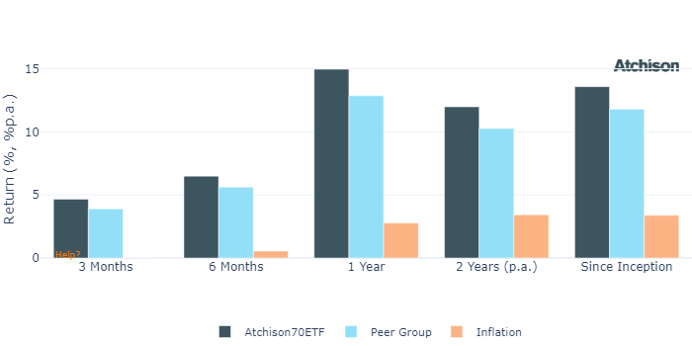

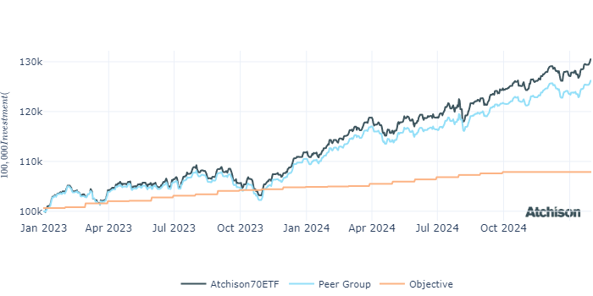

Asset Allocation

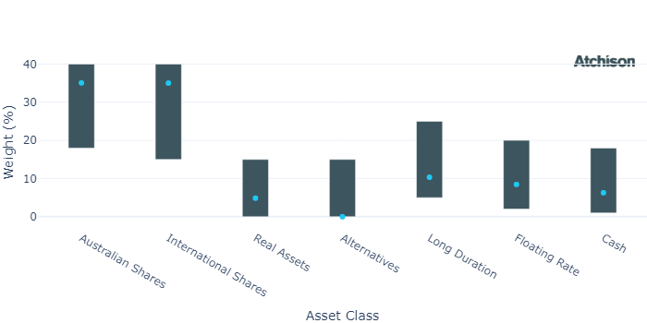

Asset Class Performance

|  |  |  |  |
| --- | --- | --- | --- |
| **Period** | **1 Year** | **2 Years (p.a.)** | **Since Inception** |
| Australian Shares | 14.16 | 10.14 | 12.89 |
| International Shares | 23.47 | 20.33 | 21.63 |
| Real Assets | 15.75 | 9.09 | 11.13 |
| Alternatives | 0.0 | 0.0 | 0.0 |
| Long Duration | 2.2 | 2.37 | 3.65 |
| Floating Rate | 5.59 | 4.9 | 4.82 |
| Cash | 4.57 | 4.31 | 4.29 |

Portfolio Construction

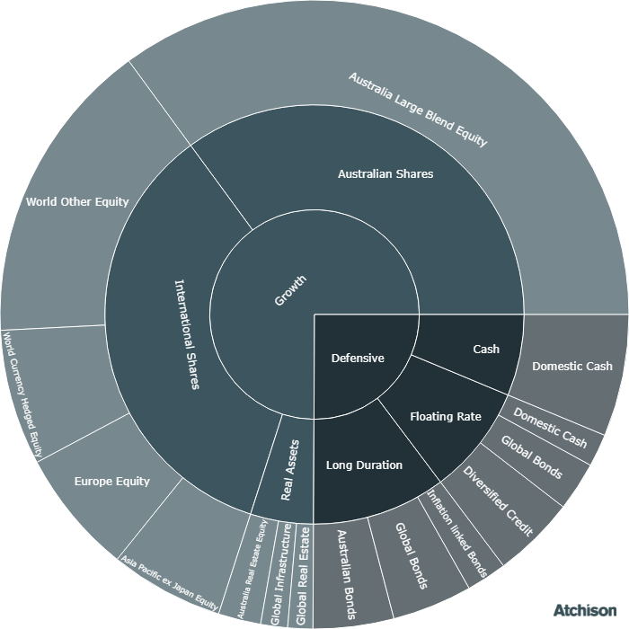

Correlations

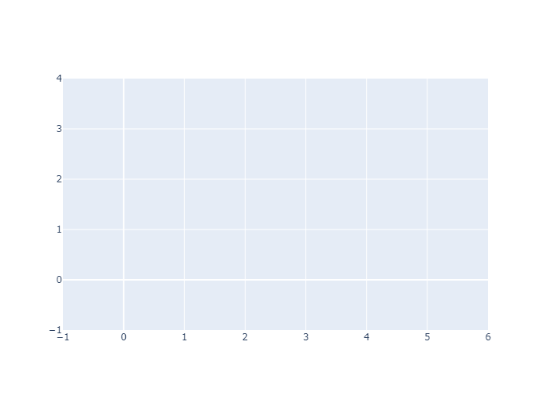

1 Year Performance Heatmap

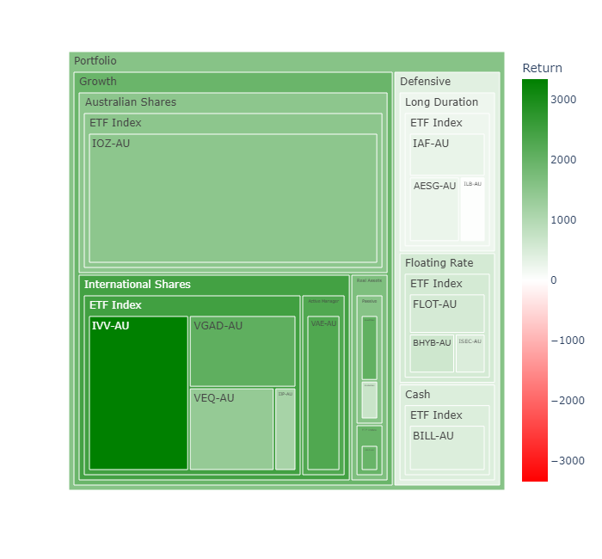

Top 10 Share Exposures

|  |  |
| --- | --- |
| **Code** | **Name** |
| BHP-AU | BHP Group Limited |
| CBA-AU | Commonwealth Bank of Australia |
| CSL-AU | CSL Limited |
| NAB-AU | National Australia Bank Limited |
| ANZ-AU | ANZ Group Holdings Limited |
| WBC-AU | Westpac Banking Corporation |
| WDS-AU | Woodside Energy Group Ltd |
| MQG-AU | Macquarie Group Limited |
| WES-AU | Wesfarmers Limited |
| MSFT.NAS | MICROSOFT CORP |

Historical Allocation Changes

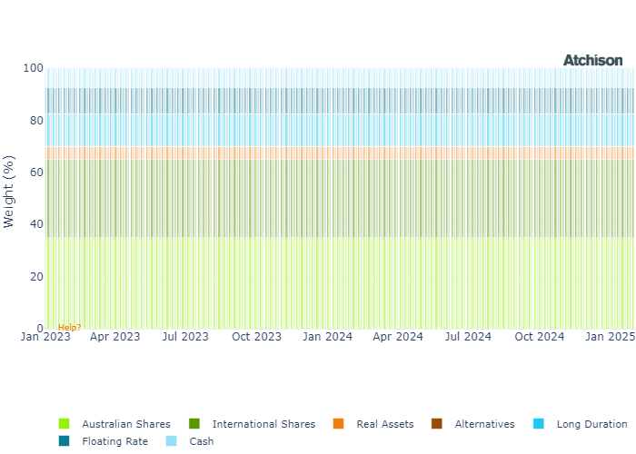

Market Update

Australian stocks surged, with the S&P/ASX 200 gaining 4.6% and hitting a record high. Ten of eleven sectors in the ASX 200 rose, with Consumer Discretionary up 7.1% and Financials up 6.1%. Utilities were the only sector in negative territory (-2.4%) for the month.  
  
Utilities are defensive stocks that tend to outperform in low-rate environments due to their stable, bond-like dividend returns. However, as bond yields rose in early January, fixed income became more attractive relative to utilities, leading to a rotation out of the sector.  
  
The S&P 500 hit a record high early in the month before a sharp decline triggered by the launch of a new AI model, Deep Seek, from China. However, strong earnings and consumer spending helped the index finish with a 3% monthly gain. US Mid-Cap (3.9%) and Small-Cap (2.9%) companies outperformed the S&P 500 (2.8%) in January. Investors remain cautious about potential Fed rate cuts, inflation, already high valuations on Mega Caps, implications of Deep Seek, and potential trade tariff retaliation affecting neighboring US partners.Most sectors saw positive returns, led by Communication Services, Health Care, and Financials. Technology was the only sector to decline (-2.9%), facing headwinds from AI-related concerns.  
  
European stocks surged in January, driven by interest rate cuts and resilience to AI-related volatility. The FTSE 100 climbed 6.8%. Financials and Technology led gains, both up 8.4%, while Consumer Staples and Real Estate underperformed, rising just 2.2% and 2.4%. Despite European mid- and small-cap stocks rising, they trailed large caps, gaining 5.9% and 3.8%, respectively.  
  
Bond markets gained across the board, supported by falling 10-year Treasury yields and a flight to safety amid market volatility. High-yield credit outperformed investment-grade bonds, reflecting stronger investor risk appetite.  
  
Australian bonds were mostly positive, as markets priced in an 80% probability of an RBA rate cut in February. This expectation drove bond yields lower and prices higher, in line with broader expectations of global monetary easing.  
  
Eurozone government bonds declined in January as markets had already priced in expected ECB rate cuts. Additionally, improved economic sentiment led investors to rotate out of safe-haven bonds and into riskier assets. Meanwhile, European corporate and high-yield bonds rose, benefiting from narrowing credit spreads, as investors perceived lower risk in corporate debt due to anticipated lower borrowing costs.  
  
Gold reached another record high, driving strong gains in Precious Metals, as investors sought safe-haven assets amid tariff uncertainty.

Fine Print

Important Notice: This document is published by TAG Asset Consulting Group Pty Ltd, trading as Atchison Consultants, ABN 58 097 703 047, AFSL 230 846. Atchison Consultants distributes its investment solutions via platform and dealer groups (financial advisory groups).

Warning: Please be advised that past performance is not indicative of future performance. The returns discussed herein are based on model asset allocations and are for illustrative purposes only. Actual returns may differ due to variations in fees, timing of model change implementation, and the need to substitute individual holdings where reliable data was not available from our data providers. Any insights or recommendations provided in this document are intended for general advice purposes only and are based on our opinion of the investment merits of the financial products discussed, independent of the financial circumstances of any individual. Before proceeding with any investment based on the information provided, recipients must assess its suitability to their financial situation and consider seeking advice from an independent financial advisor.

Disclaimer: While care is taken to ensure the accuracy and completeness of the information presented herein, no warranties or representations are made as to its reliability. The content provided is derived from publicly available sources, or external data providers, which have not been independently verified by Atchison Consultants. Atchison Consultants, along with its directors, officers, employees, and agents, expressly disclaims any liability for errors, inaccuracies, or omissions in this document, as well as for any loss or damage that may arise from reliance on its contents. Readers are cautioned to verify all information independently before taking any actions based on this report.